Thread Synchronization in Java
- Write a program that demonstrates the problem of resource conflict: Suppose that you create and launch ten threads, each of which increments an integer variable (x) by 1. (initialize x = 0)

//No synchronisation
public class Q1 {
public static void main(String[] args) {
Taskclass t1 = new Taskclass();
Thread m1 = new Thread(t1);
Thread m2 = new Thread(t1);
Thread m3 = new Thread(t1);
Thread m4 = new Thread(t1);
Thread m5 = new Thread(t1);
Thread m6 = new Thread(t1);
Thread m7 = new Thread(t1);
Thread m8 = new Thread(t1);
Thread m9 = new Thread(t1);
Thread m10 = new Thread(t1);
m1.start();
m2.start();
m3.start();
m4.start();
m5.start();
m6.start();
m7.start();
m8.start();
m9.start();
m10.start();
try {
m1.join();
m2.join();
m3.join();
m4.join();
m5.join();
m6.join();
m7.join();
m8.join();
m9.join();
m10.join();
} catch (InterruptedException ex) {
System.out.println(ex);
}
System.out.println(t1.getX());
}
}
class Taskclass implements Runnable {
private int x = 0;
@Override
public void run() {
for (int i = 0; i < 1000; i++) {
x++;
}
}
int getX() {
return x;
}
}
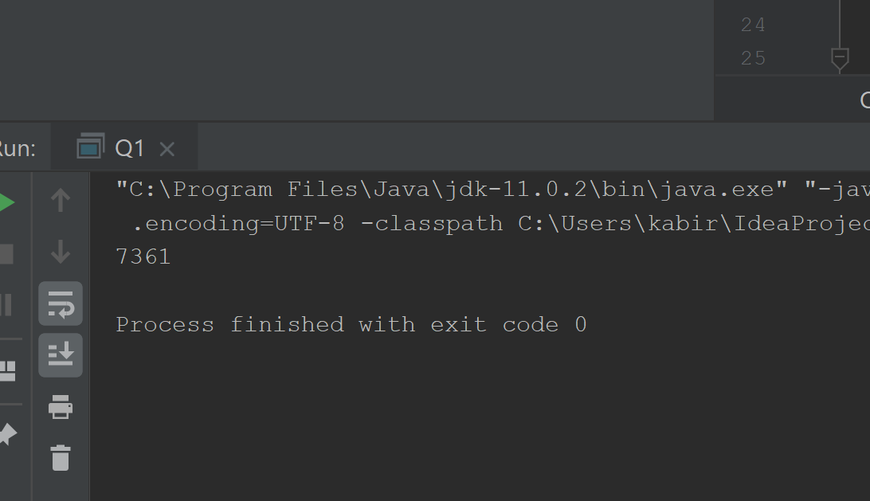

- To avoid race conditions, repeat above question using: a) synchronized keyword, b) explicit locks.
//With synchronised keyword
public class Q1 {
public static void main(String[] args) {
Taskclass t1 = new Taskclass();
Thread m1 = new Thread(t1);
Thread m2 = new Thread(t1);
Thread m3 = new Thread(t1);
Thread m4 = new Thread(t1);
Thread m5 = new Thread(t1);
Thread m6 = new Thread(t1);
Thread m7 = new Thread(t1);
Thread m8 = new Thread(t1);
Thread m9 = new Thread(t1);
Thread m10 = new Thread(t1);
m1.start();
m2.start();
m3.start();
m4.start();
m5.start();
m6.start();
m7.start();
m8.start();
m9.start();
m10.start();
try {
m1.join();
m2.join();
m3.join();
m4.join();
m5.join();
m6.join();
m7.join();
m8.join();
m9.join();
m10.join();
} catch (InterruptedException ex) {
System.out.println(ex);
}
System.out.println(t1.getX());
}
}
class Taskclass implements Runnable {
Temp temp = new Temp();
int getX() {
return temp.x;
}
@Override
public void run() {
temp.print();
}
}
class Temp {
int x = 0;
public synchronized void print() {
try {
for (int i = 0; i < 1000; i++) {
x++;
}
} catch (Exception ex) {
System.out.println(ex);
}
}
}
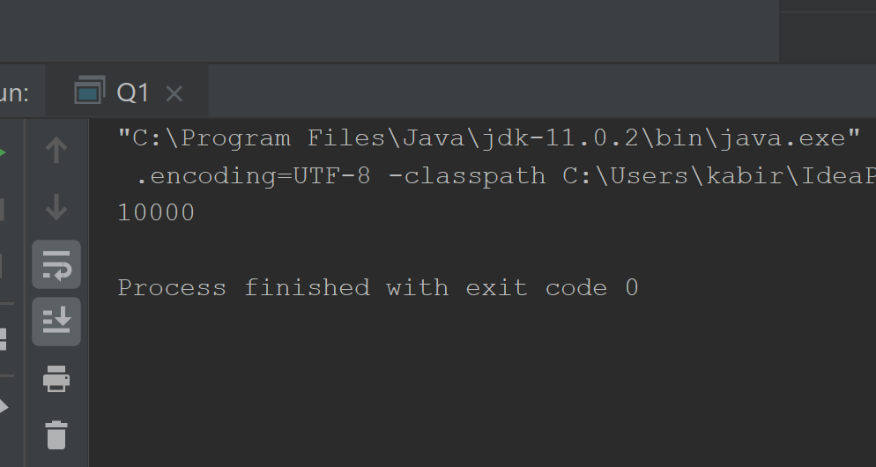
//With explicit locks
import java.util.concurrent.locks.ReentrantLock;
import java.util.concurrent.locks.Lock;
public class Q1 {
public static void main(String[] args) {
Taskclass t1 = new Taskclass();
Thread m1 = new Thread(t1);
Thread m2 = new Thread(t1);
Thread m3 = new Thread(t1);
Thread m4 = new Thread(t1);
Thread m5 = new Thread(t1);
Thread m6 = new Thread(t1);
Thread m7 = new Thread(t1);
Thread m8 = new Thread(t1);
Thread m9 = new Thread(t1);
Thread m10 = new Thread(t1);
m1.start();
m2.start();
m3.start();
m4.start();
m5.start();
m6.start();
m7.start();
m8.start();
m9.start();
m10.start();
try {
m1.join();
m2.join();
m3.join();
m4.join();
m5.join();
m6.join();
m7.join();
m8.join();
m9.join();
m10.join();
} catch (InterruptedException ex) {
System.out.println(ex);
}
System.out.println(t1.getX());
}
}
class Taskclass implements Runnable {
Temp temp = new Temp();
int getX() {
return temp.x;
}
@Override
public void run() {
temp.print();
}
}
class Temp {
int x = 0;
private static Lock lock1 = new ReentrantLock();
public void print() {
lock1.lock();
try {
for (int i = 0; i < 1000; i++) {
x++;
}
} catch (Exception ex) {
System.out.println(ex);
}
lock1.unlock();
}
}
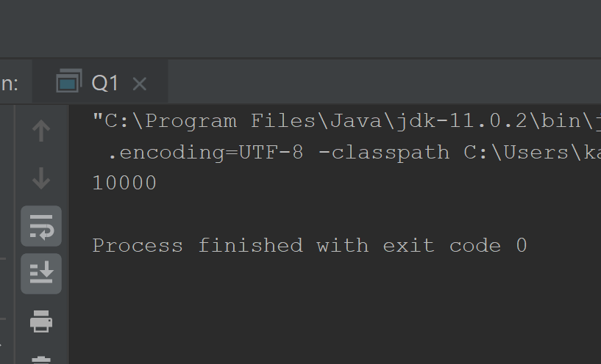

- Write a program that constructs 4 threads. Each thread prints an alphabet 5 times. An output would be: AAAAABBBBBCCCCCDDDDD. Using synchronized keyword, produce the above output. The goal is that the alphabets printed from these thread stay together). Your output will not necessarily be in the above order.
public class Q3 {
//With synchronised keyword
public static void main(String[] args) {
Task t1 = new Task();
Thread m1 = new Thread(t1);
Thread m2 = new Thread(t1);
Thread m3 = new Thread(t1);
Thread m4 = new Thread(t1);
m1.start();
m2.start();
m3.start();
m4.start();
}
}
class Task implements Runnable {
Tempclass c1 = new Tempclass();
@Override
public void run() {
c1.print();
}
}
class Tempclass {
private static boolean check[] = new boolean[4];
private char[] ch = {'A', 'B', 'C', 'D'};
public synchronized void print() {
int flag = 0;
while (true) {
int x = (int) (Math.random() * 4);
if (check[x] == false) {
for (int i = 0; i < 5; ++i) {
System.out.print(ch[x]);
}
flag = 1;
check[x] = true;
}
if (flag == 1)
break;
}
}
}
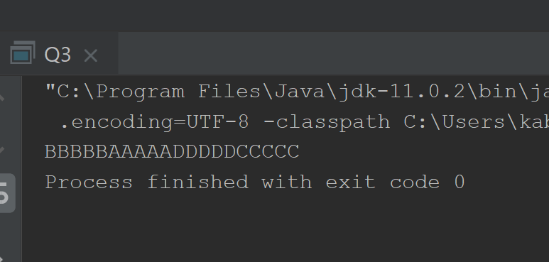

- Write a program that constructs 4 threads. Each thread prints a number twice. An output would be: 11223344. Using a single lock common to all threads, produce the above output. The goal is that the numbers printed from these thread stay together). Your output will not necessarily be in the above order.
import java.util.concurrent.locks.Lock;
import java.util.concurrent.locks.ReentrantLock;
public class Q4 {
//With synchronised keyword
public static void main(String[] args) {
Tasks t1 = new Tasks();
Thread m1 = new Thread(t1);
Thread m2 = new Thread(t1);
Thread m3 = new Thread(t1);
Thread m4 = new Thread(t1);
m1.start();
m2.start();
m3.start();
m4.start();
}
}
class Tasks implements Runnable {
Temp c1 = new Temp();
@Override
public void run() {
c1.print();
}
}
class Temp {
private static Lock lock1 = new ReentrantLock();
private static boolean check[] = new boolean[4];
private int[] ch = {1,2,3,4};
public void print() {
lock1.lock();
int flag = 0;
while (true) {
int x = (int) (Math.random() * 4);
if (check[x] == false) {
for (int i = 0; i < 2; ++i) {
System.out.print(ch[x]);
}
flag = 1;
check[x] = true;
}
if (flag == 1)
break;
}
lock1.unlock();
}
}
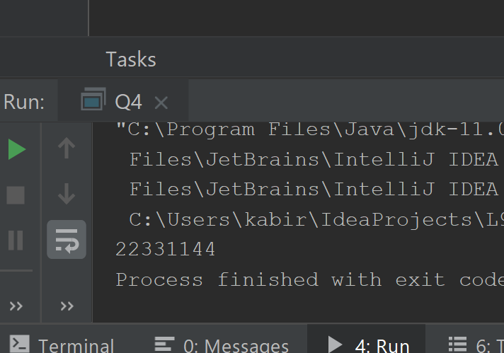

- Write a multithreaded sorting program in Java that works as follows: A collection of integers is divided into two lists of equal (or, nearly equal if number of elements is odd) size. Each sublist is then passed to a separate thread (a sorting thread), which sorts the list using any sorting algorithm of your choice. The two sorted lists are then passed to a third thread (a merge thread), which merges the two separate lists into a single sorted list. Once the two sublists have been merged, the complete sorted list is the final output. Your main() method should create the original list of random integers. The size of the list must be random. (Use methods of Thread class)
import java.util.Arrays;
public class Q5 {
public static void main(String[] args) throws InterruptedException {
int n = (int) (Math.random() * 100);
int[] arr = new int[n];
for (int i = 0; i < n; ++i) {
arr[i] = (int) (Math.random() * 100);
}
int[] arr1 = new int[n / 2];
int[] arr2 = new int[n - n / 2];
for (int i = 0, j = 0, k = 0; i < n; ++i) {
if (i < n / 2) {
arr1[j] = arr[i];
++j;
} else {
arr2[k] = arr[i];
++k;
}
}
System.out.print("Number of elements: " + n);
System.out.print("\nOriginal array: ");
for (int i = 0; i < n; ++i)
System.out.print(arr[i] + " ");
System.out.print("\n\nSublist 1 (Unsorted): ");
for (int i = 0; i < arr1.length; ++i)
System.out.print(arr1[i] + " ");
System.out.print("\nSublist 2 (Unsorted): ");
for (int i = 0; i < arr2.length; ++i)
System.out.print(arr2[i] + " ");
Sort s1 = new Sort();
Sort s2 = new Sort();
s1.sort(arr1);
s2.sort(arr2);
s1.start();
s2.start();
try {
s1.join();
s2.join();
} catch (InterruptedException e) {
e.printStackTrace();
}
System.out.print("\n\nSublist 1 (Sorted): ");
for (int i = 0; i < arr1.length; ++i)
System.out.print(arr1[i] + " ");
System.out.print("\nSublist 2 (Sorted): ");
for (int i = 0; i < arr2.length; ++i)
System.out.print(arr2[i] + " ");
Merge m1 = new Merge();
m1.merge(arr, arr1, arr2);
m1.start();
m1.join();
System.out.print("\nSorted array: ");
for (int i = 0; i < n; ++i)
System.out.print(arr[i] + " ");
}
}
class Sort extends Thread {
private int[] a;
public void sort(int[] arr) {
a = arr;
}
@Override
public void run() {
go();
}
private void go() {
Arrays.sort(a);
}
}
class Merge extends Thread {
private int[] a1;
private int[] a2;
private int[] a3;
public void merge(int[] m1, int[] m2, int[] m3) {
a1 = m1;
a2 = m2;
a3 = m3;
}
@Override
public void run() {
go();
}
private void go() {
for (int i = 0, j = 0, k = 0; i < a1.length; ++i) {
if (j < a2.length && k < a3.length) {
if (a2[j] <= a3[k]) {
a1[i] = a2[j];
++j;
} else {
a1[i] = a3[k];
++k;
}
} else if (j < a2.length && k == a3.length) {
a1[i] = a2[j];
++j;
} else if (j == a2.length && k < a3.length) {
a1[i] = a3[k];
++k;
}
}
}
}

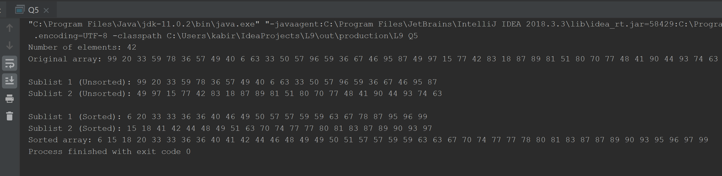
- Using explicit lock, implement this scenario: You have a bank account (with initial amount as INR 100000), from which you can withdraw money using three ATM machines (MachineA, MachineB, MachineC). No transaction should be allowed if the amount to be withdrawn is greater than the remaining balance in the account. Print the account balance after each transaction. Suppose the transactions take place in the following order:
  - INR 10000 from MachineA.
  - INR 15000 from MachineB.
  - INR 25000 from MachineA.
  - INR 60000 from MachineC.
//With explicit locks
import java.util.concurrent.locks.ReentrantLock;
import java.util.concurrent.locks.Lock;
public class Q6 {
public static void main(String[] args) throws InterruptedException {
Balance b = new Balance(100000);
MachineA mA1 = new MachineA(b, 10000);
b.setBalance((mA1.getBalance()));
mA1.start();
mA1.join();
MachineB mB1 = new MachineB(b, 15000);
b.setBalance(mB1.getBalance());
mB1.start();
mB1.join();
MachineA mA2 = new MachineA(b, 25000);
b.setBalance(mA2.getBalance());
mA2.start();
mA2.join();
MachineC mC1 = new MachineC(b, 60000);
b.setBalance(mC1.getBalance());
mC1.start();
mC1.join();
}
}
class Balance {
public int balance;
Balance(int x) {
balance = x;
}
public void setBalance(int x) {
balance = x;
}
}
class MachineA extends Thread {
Withdrawal wdl = new Withdrawal();
private int x;
private int balance;
Balance bal;
MachineA(Balance bal, int wdl) {
x = wdl;
balance = bal.balance;
this.bal=bal;
}
@Override
public void run() {
wdl.withdraw(bal, x);
}
public int getBalance() {
return balance;
}
}
class MachineB extends Thread {
Withdrawal wdl = new Withdrawal();
private int x;
private int balance;
Balance bal;
MachineB(Balance bal, int wdl) {
x = wdl;
balance = bal.balance;
this.bal=bal;
}
@Override
public void run() {
wdl.withdraw(bal, x);
}
public int getBalance() {
return balance;
}
}
class MachineC extends Thread {
Withdrawal wdl = new Withdrawal();
private int x;
private int balance;
Balance bal;
MachineC(Balance bal, int wdl) {
x = wdl;
balance = bal.balance;
this.bal=bal;
}
@Override
public void run() {
wdl.withdraw(bal, x);
}
public int getBalance() {
return balance;
}
}
class Withdrawal {
private static Lock lock1 = new ReentrantLock();
public void withdraw(Balance balance, int x) {
lock1.lock();
try {
if (balance.balance >= x) {
balance.balance -= x;
System.out.println("Balance left: " + balance.balance);
} else {
System.out.println("Transaction not allowed.");
}
} catch (Exception ex) {
System.out.println(ex);
}
lock1.unlock();
}
}

